Chapter-1: Introduction

**1.1 Description of Organisation**:

**1.1.1 General description :**

The **airline reservations system (ARS)** was one of the earliest changes to improve efficiency. ARS eventually evolved into the computer reservations system (CRS). A computer reservation system is used for the reservations of a particular airline and interfaces with a global distribution system (GDS) which supports travel agencies and other distribution channels in making reservations for most major airlines in a single system.

**Jet Airways** is the largest Indian airline based out of Mumbai, Maharashtra. It operates over 400 flights daily to 76 destinations worldwide. Its main hub is Mumbai, with secondary hubs at Delhi, Kolkata, Chennai, Cochin, Ahmedabad, and Bengaluru. It has an international hub at Brussels Airport, Belgium. Jet Airways is owned by Naresh Goyal.

Jet Airways's head office is located in the Siroya Centre in Andheri, Mumbai

Jet Airways serves 52 domestic destinations and 24 international destinations, a total of 76 in 19 countries across southern Africa, Asia, Europe and North America. Short-haul destinations are served using Boeing 737 Next Generation. ATR 72-500s are used only on domestic regional routes, while long-haul routes are served using its Airbus A330-200 and Boeing 777-300ER aircraft. London, England was the airline's first long-haul destination and was launched in 2005.

**1.1.2 Organisational objectives**

Jet Airways will achieve these objectives:-

1. simultaneously ensuring consistent profitability
2. achieving healthy, long-term returns for the investors
3. Providing its employees with an environment for excellence and growth.
4. Providing Comforts in all zones while traveling to the customers.
5. Giving a quick response on any query raised either by employee or by customer.
6. Achieving goal in hanging up with customer in a increasing percentage year by year
7. They are trying to upgrade the concept of domestic airline travel to be a world class domestic airline.

**1.1.3 Key Result Areas (KRAs)**

1. **On Ground Services**: It is the process of booking ticket or checking in for flight, It ensures that every need on the ground is met.
2. **Check-in options** : Jet Airways offer multiple check-in options.
3. **Airport Lounges** : Jet Privilege Silver, Gold or Platinum card member or a Club Premiere passenger, can relax and enjoy complimentary snacks and beverages in jet Airways’ plush airport lounges.
4. **Coach Services** : Airport Authority of India (A. A. I.) operates shuttle coaches for transit passengers from domestic to international airport and vice-versa at Mumbai and Delhi airports.
5. **Complimentary Chauffeur Drive :** A service specially for PREMIERE passengers traveling between Mumbai/Delhi and London (Heathrow).
6. **In-Flight Services** : Jet Airways continually endeavours to better its services, both on the ground and in the air. From crew, whose priority is passengers’ comfort to the safety standards enforced to ensure that one is free of worr

**1.1.4 Organisational structure of Jet Airways**

Jet Airways is led by a dynamic, extremely talented and experianced team:

CEO

Finance

&

Humana resource

Sales

Secretary

Network Planning

& Revenue

Legal

Executive officer

Procurement

& Properties

Alliance

&

planning

Sales

Public Relations

Communication & public Relation

Cabin crew

Sales Strategy & Investors

Customer

services

**Figure N0-1 Data Flow Diagram of Organizational Structure**

**1.1.5 Functions/activities of organization in reference to the information system under**

**study.**

1. **Online ticketing Reservation at jetairways.com: It Book**, pay and print your tickets instantly. Also, book multiple sectors for domestic and international flight at jetairways.com.
2. **IVR Interactive Voice Response: It** Book and pay for your tickets through our 24x7 call center over a secure IVR, and get your tickets via e-mail.
3. **Mobile Ticketing with Jet Wallet:** Book, pay and generate your eTicket. SMS ‘Jet Wallet’ to 56388 to download Jet Wallet on your GPRS phone.
4. **Pay Online service:** Book your ticket at Jet Airways reservation office and pay online at jetairways.com.
5. **Web Check-in:** Select your seat, print your boarding pass and proceed directly for security check.
6. **SMS Check-in**: Check-in anytime, anywhere and avail of a confirmed seat number on your mobile phone.
7. **Kiosk Check-in:** New age Kiosks at select airports in India help you select your seat and print your boarding pass at the touch of a screen.
8. **Bus service:** To make travel simpler, Jet Airways now provides a bus service to transport guests travelling to Dammam via Bahrain and vice-versa through King Fahad Causeway
9. **Secure Flight Passenger Data:** The United States Transportation Security Administration (TSA) has introduced a new ‘Secure Flight Passenger Data’ system for all guests travelling to / from the United States Of America.  
     
   The ‘Secure Flight Passenger Data’ system is also applicable to all guests travelling to / from / within Canada and flying over continental U.S.   
     
   Transportation Security Administration (TSA) requires you to provide the below information:

* Full Name (Your name as it appears on your passport)
* Date of Birth
* Gender
* Redress Number (if available)

1. **IVR Ticketing :** **Interactive Voice Response (IVR) based Payment and Ticketing**

Jet Airways’ IVR based payment and ticketing service is the latest booking facility through our 24*7 call centre. Now book and pay for your eTickets over an exclusively customized and secure Interactive Voice Response (IVR) system.

Our IVR service allows you to complete your reservation, pay using credit cards through a secure gateway and instantly receive your eTickets via e-mail.

Once you confirm that you want to pay through the contact centre, our contact centre executive will transfer you to a secure IVR system that will request you to enter your credit card details. On a successful authorization of the credit card, you will get an automated response and your

|  |
| --- |
|  |
|  |
|  |
|  |

**1.2 Data Collection**

**1.2.1 Description of method/source of collection of data for each set of data**

These are the links of sites from where we got the data about the topic which we got:-

http://en.wikipedia.org/wiki/Jet_Airways

http://www.yatra.com/YT/airlines/jet-airways.html

http://www.jetairways.com/EN/IN/Home.aspx?gclid=CKuq28TeyrACFUZ76wodgz0OXQ

Jet airways office:

13 Commercial Centre, Jet Air House, Yusuf Sarai, Yusuf Sarai  New Delhi, Delhi 110016  
011 25675404

**1.2.2 Primary data Collection :-**  It involves collecting data by means of direct interactions with the human subject. Examples of such methods used are interviews, questionnaires, observations, measurements, and abstractions from medical records. It is divided in two parts :- Interview & questionnaire.

* 1. **Questionnaire**

1. Which airlines you prefer to travel by??

Jet airways Kingfisher

Indigo Lufthansa

1. You prefer to book airlines ticket by??

Agent Online

Airport Phone

1. Which airline is good for providing services??

Jet airways Indigo

Lufthansa Kingfisher

1. According to you which airlines provide you all comforts as it gives words??

Jet airways Indigo

Lufthansa Kingfisher

1. You are fit to fly from which airline service??

Jet airways Kingfisher

Indigo Lufthansa

1. You prefer to have meal in flight ??

Yes No

Sometimes Always

1. You book your meal in flight??

At the time of booking ticket Manage Booking facility

Before departure In flight

1. You prefer to travel in ??

Business class Economy class

General class In any

* 1. **Interview**
     1. In which site you search for booking the airline ticket?
     2. Which airlines you prefer to travel by?
     3. According to you the price of the flight tickets should be reduced or not and if yes then why?
     4. Which class you prefer to travel in for a long flight route?
     5. Why do you prefer travelling from flight rather than from other means of transport?
     6. How you easily book you airline ticket?
     7. Do airlines provide all the comfort about which they give words?
     8. According to you which flight is best to travel in, with a normal cost, good meal, & best services?

**1.2.3Secondary Data Collection: -** It involves data that additionally arise from the processing of data when the product or service is used (e.g., usage data, log files, statistical data, data for authorization, configuration data). It involves document analysis & internet.

* **Document analysis**

Recent document analysis has been done on jet airway, which was done by Jet Airways (India) limited company on the Company’s profile & SWOT analysis.

They have introduced all the factors in all fields. Like:-

1. Fast facts
2. SWOT analysis
3. Revenue & margin
4. Return on Equity
5. **Fast Fact**

|  |  |
| --- | --- |
| Headquarter Address | Siroya Centre, Mumbai 400 059, India |
| Telephone  FAX  Website | +91 22 61211000  +91 22 285051313  [www.jetairways.com](http://www.jetairways.com) |
| Ticker Symbol, Stock Exchange | 532617, Bombay Stock  ExchangeJETAIRWAYS, National Stock  Exchange of India |
| Number of Employees | 13, 177 |
| Fiscal year End  Revenue (in US$ million) | March  3, 205.70 |
| Revenue(in INR million) | 147,296.80 |

**Table No- 1: Data of Fast Fact of JetAirways**

1. **SWOT analysis**

|  |  |
| --- | --- |
| SWOT Analysis | |
| **Strengths** | **Weaknesses** |
| Broad range of airlines services | Limited financial Liverages |
| Jetprivilege program |  |
| Leading market position In india  Strong business patnerships |  |
| String liquidity position |  |
| Strong operating performances |  |
| **OPPORTUNITIES** | **THREATS** |
| Government initiatives to promote tourism | Foreign currency fluctuations |
| New services launches  Recovery in global travel & tourism industry | Increasing fuel price  Political unrest in the Middle East & Northj Africa |
|  | Unforeseen Circumstances |

**Table No-2: Table of SWOT Analysis of JetAirways**

Operating performances

The company reported revenue of US$3,205.70 million during the fiscal year 2011. The company’s revenue grew at a CAGR of 15.68% during 2007-2011, with an annual growth of 20.34% over 2010. In 2011, the company recorded an operating margine of -0.33% as against -3.35% in 2010

1. **Revenue & Margins**

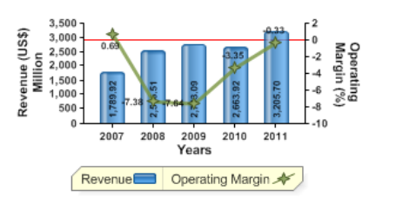

**Figure N0-2: Graph Of Revenue & Margins**

1. **Return on Equity**

The company recorded a return on equity ROE of 2.58% for 2011, as compare to its peers, spiceJet limited, Kingfisher Airlines Limited & Global Vectra Helicorp Limited, which recorded ROE’s of 9.92%, 42.86% & -55.74% respectively. The company reported on operating margin of -0.33% in 2011

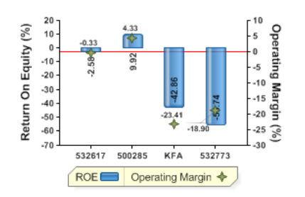

**Figure N0-3: Graph Of Return of Equity**

* **Internet**

1. http://en.wikipedia.org/wiki/Airline_reservations_system
2. http://www.makemytrip.com/flights/bangalore-jet_airways.html
3. http://www.yatra.com/YT/airlines/jet-airways.html

**1.2.4 Storage and processing requirements**

None

**1.3. Project Planning**

**1.3.1 Plan of distribution of work amongst the team members**

**1.3.2. Name of task/activity, Precedence/order (date-wise) in which these are performed**

**and name of team member**

|  |  |  |  |  |
| --- | --- | --- | --- | --- |
| **S. NO** | **Task Name** | **Start** | **Finish** | **Resource Names** |
| 1 | **Chapter 1 1: Introduction** | 6/11/12 | 6/25/12 | Harish Singh Bisht, Geetanjali |
| 2 | **1.1 Description of Organization** | 6/11/12 | 6/14/12 | Geetanjali |
| 3 | **1.1.1 General description** | 6/11/12 | 6/11/12 | Geetanjali |
| 4 | 1.1.2 Organisational objectives | 6/11/12 | 6/11/12 | Harish Singh Bisht |
| 5 | 1.1.3 Key Result Areas | 6/12/12 | 6/12/12 | Harish Singh Bisht |
| 6 | 1.1.4 Organisational structure | 6/13/12 | 6/13/12 | Geetanjali |
| 7 | 1.1.5 Functions/activities of organization | 6/13/12 | 6/14/12 | Geetanjali |
| 8 | **1.2 Data Collection** | 6/15/12 | 6/17/12 | Harish Singh Bisht, Geetanjali |
| 9 | 1.2.1 Description of method/source of collection | 6/15/12 | 6/15/12 | Geetanjali |
| 10 | 1.2.2 Primary data Collection | 6/16/12 | 6/16/12 | Harish Singh Bisht |
| 11 | 1.2.3 Secondary Data Collection | 6/16/12 | 6/17/12 | Geetanjali |
| 12 | 1.2.4 Storage and processing requirements | 6/17/12 | 6/17/12 | Harish Singh Bisht |
| 13 | **1.3. Project Planning:** | 6/18/12 | 6/22/12 | Geetanjali |
| 14 | 1.3.1 Plan of distribution of work | 6/18/12 | 6/18/12 | Harish Singh Bisht |
| 15 | 1.3.2. Name of task/activity, Precedence/order | 6/19/12 | 6/19/12 | Geetanjali |
| 16 | 1.3.3Proposed Methodology or Technique of Project Design | 6/20/12 | 6/21/12 | Harish Singh Bisht |
| 17 | 1.3.4 Gantt chart | 6/22/12 | 6/28/12 | Geetanjali |
| 18 | Submission Chapter-01 | 6/29/12 | 6/30/12 | Harish Singh Bisht, Geetanjali |
| 19 | Chapter-2: System Analysis | 7/2/12 | 7/14/12 | Harish Singh Bisht, Geetanjali |
| 20 | **2.1 Description of Information System:** | 7/2/12 | 7/9/12 | Harish Singh Bisht |
| 21 | 2.1.1Description of the functioning of information system under study in n, Functional ‘Block Diagram’arrative form in | 7/2/12 | 7/4/12 | Harish Singh Bisht |
| 22 | 2.1.2List of Processes included in the information system under study | 7/4/12 | 7/5/12 | Geetanjali |
| 23 | 2.1.3List of Input & Output for each process identified | 7/5/12 | 7/5/12 | Geetanjali |
| 24 | 2.1.4List of data elements connected with each process identified | 7/5/12 | 7/6/12 | Geetanjali |
| 25 | 2.1.5Catalogue of data elements is to be presented in tabular form | 7/15/12 | 7/15/12 | Geetanjali |
| 26 | **2.2 procedures/rules/mathematical relationships used for converting input into output** | 7/15/12 | 7/16/12 | Harish Singh Bisht |
| 27 | Chapter-3: Systems Requirement Specification (SRS) | 7/15/12 | 7/27/12 | Harish Singh Bisht, Geetanjali |
| 28 | **3.1 Physical Specifications:** | 7/15/12 | 7/16/12 | Harish Singh Bisht |
| 29 | 3.1.1DFD | 7/15/12 | 7/15/12 | Harish Singh Bisht |
| 30 | 3.1.2ERD | 7/16/12 | 7/16/12 | Harish Singh Bisht |
| 31 | **3.2 Output Specifications:** | 7/30/12 | 7/31/12 | Geetanjali |
| 32 | 3.2.1Detailed characteristics of contents (fields) to be included in each Output Screen and Print layouts. | 7/17/12 | 7/17/12 | Geetanjali |
| 33 | 3.2.2List of data elements (comprising Field Name, Field Type, Field Size & description) for each Output presented in the tabular form. | 7/18/12 | 7/18/12 | Geetanjali |
| 34 | **3.3 Input Specifications:** | 8/1/12 | 8/3/12 | Harish Singh Bisht |
| 35 | 3.3.1Detailed characteristics of contents (fields) to be included in each Input screen or document. | 7/30/12 | 7/31/12 | Harish Singh Bisht |
| 36 | 3.3.2List of data elements (comprising Field Name, Field Type, Field Size & description) for each Input presented in the tabular form . | 7/20/12 | 7/21/12 | Harish Singh Bisht |
| 37 | **3.4 Validation Specifications:** | 7/23/12 | 7/23/12 | Geetanjali |
| 38 | 3.4.1Description of the validation rules to be included for input/output, wherever required. | 7/23/12 | 7/23/12 | Geetanjali |
| 39 | **3.5 Database Specifications** | 8/1/12 | 8/2/12 | Geetanjali |
| 40 | 3.5.1Detailed characteristic of fields of each file/table included in the database are to be tabulated with Field Name, Type, and Size & Description | 8/6/12 | 8/7/12 | Geetanjali |
| 41 | **3.6 Processing Logic:** | 7/26/12 | 7/30/12 | Harish Singh Bisht |
| 42 | 3.6.1 Programme Flow Chart. | 8/1/12 | 8/2/12 | Harish Singh Bisht |

**Table N0-3: Table of Project planning among partners**

**1.3.3 Proposed Methodology or Technique of Project Design**

The Waterfall Model of Software Development Life Cycle has been used for the development of this project. It is the simplest and most basic approach used to develop software wherein each phase has a well-defined starting and end point. No backtracking is permissible under this approach

Operation and Maintenance

Integration and system Testing

Implementation and Unit Testing

Design

Requirement analysis and Specification

**Figure N0-4: Data Flow Diagram of Waterfall Model**

**1.3.4** **Gantt charts using MS Project.**

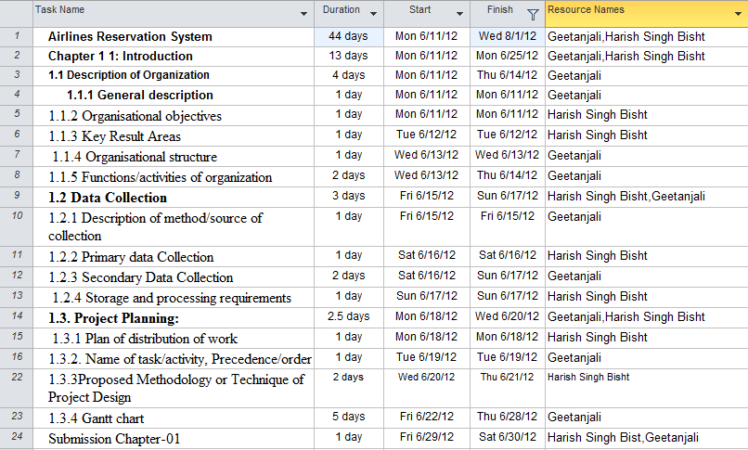

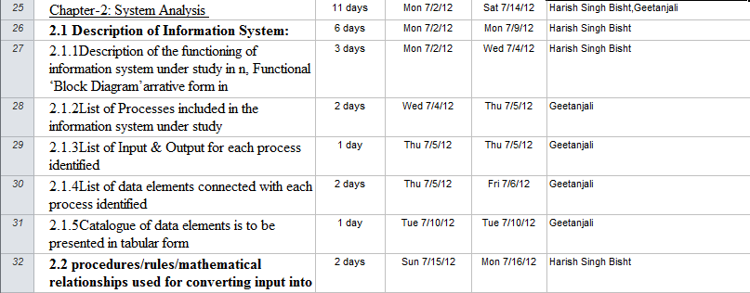

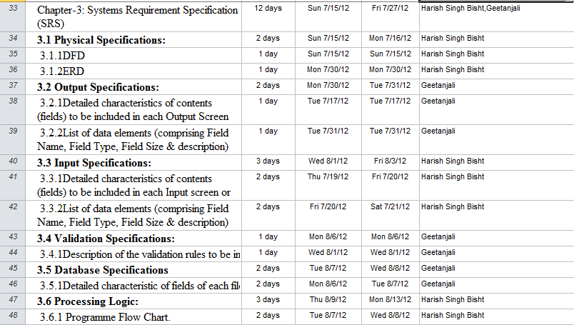

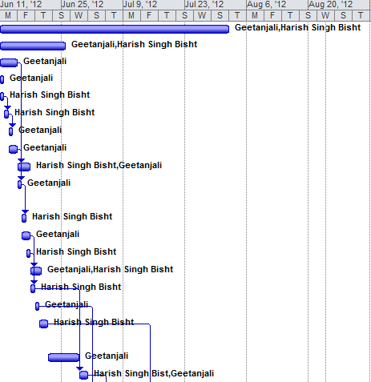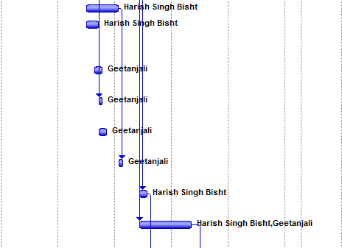

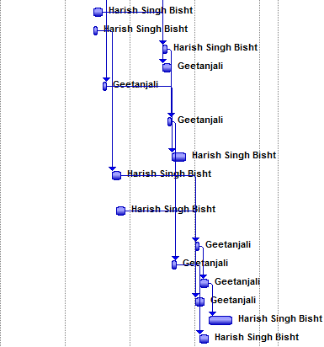

**Figure N0-5: Gant chart of project**

**Chapter-2: System Analysis**

**2.1 Description of Information System**:

**2.1.1 Description of the functioning of information system under study in narrative form in Details. Functional ‘Block Diagram’.**

Data Entry Operator

Verifying

Login

Login list

Verified

Flight Details Customer & Reservation Detail PNR no

Flight Detail Maintenance

Cancellation

Customer& Reservation Detail Maintenance

**Verified**

Verifying Verified Verifying Verified verifying

Customer& Reservation List

**Flight Detail**

Flight List

Verified Verifying

Flight Query

**Figure N0-6:- Block Diagram**

It is the study of systems — sets of interacting entities, including computer systems. This field is closely related to operations research. It is also "an explicit formal inquiry carried out to help someone, referred to as the decision maker, identify a better course of action and make a better decision than he might have otherwise made.

**2.1.2List of Processes included in the information system under study.**

**1. Login process**

In this process, operator can access the software by putting id and password. If id and password is correct he/she can access the software.

**2. Sales ticket process**

In this process, the operator checks ticket details and verify the details of the tickets from the list.

**3. Check availability**

In this process, the operator checks availability of the desired ticket for customers according to their choice.

**4. Invoice/Bill**

In this process, the operator can generate the invoice/bill by checking the price of the ticket.

**2.1.3 List of Input & Output for each process identified**

This section contains the details about all the processes that are performed in the software system and also tells us about the input and output identification i.e. what is the input being given and what is the desired output.

**1. Login process**

**Input:** id, password.

**Process:** Operator will enter his/her ID and password, if valid user then he’ll/she’ll be logged in and can now sale tickets, update the details, and check total collection came out after sealing tickets

**Output:** The operator now can perform the various operations i.e. sells, updation, deletion of tickets

**2. Sales order process**

**Input:** Selecting the item, item code, date of tickets to be reserve on, quantity of tickets done.

**Process:** Operator will select the item, date of order, and its quantity ordered as per customer’s giving order.

**Output:** This process results into generation of tickets .

**3. Check availability**

**Input:** The operator updates the new arrived or remained tickets.

**Process:** The operator enters the new arrived tickets & includes the tickets which got cancelled

**Output:** The new items added are now available along with its manufacturing date and date of expiry.

**4. Invoice/Bill**

**Input:** The operator enters the price of the tickets and quantity of tickets reserved.

**Process:** The operator enters the ticket number or reads its bar code with the help of bar code reader, enter price of each tickets, discount given if any.

**Output:** The bill of sold tickets are now available along with it price of each tickets and tax applied on it, and name of flight of which the customer have been reserved the tickets.

**2.1.5Catalogue of data elements is to be presented in tabular form.**

|  |  |
| --- | --- |
| **INPUT/OUTPUT**  **NAME** | **DATA ELEMENTS** |
| **Login** | * user_id * Password. |
| Customer | * Customer name * address * contact no * e-mail id. |
| Sales order | * Item name * Date of order. * Quantity of order. |
| Availability | * Item name. * No of items available in stock |
| Invoice/Bill | * Bar code * Price list * Quantity of items |

**Table No- 4 :- Data element to be presented**

**2.2 procedures/rules/mathematical relationships used for converting input into output**

1. Flight No = flight company name (first 3 words) + date + random no (1-100)

Example kingfisher on date 23-8-2012

So flight no is kin2382012

1. PNR No =First name of customer(first 3 words) + Last 5 no of mobile no + random no (1-100)

Example customer name is shamid khan and mobile no is 9834598238

So PNR No is sha98238

**Chapter-3: Systems Requirement Specification (SRS)**

**3.1 Physical Specifications**:

**3.1.1 DFD**

Data Entry Operator

Login Details

Booking detail

Cancellation

Detail of flight

**Ticket**

**Figure N0-7: Data Flow Diagram of 0 level DFD of ticket booking**

verifying

Uid & Passwd Login Detail

Data Entry Operator

verified

Customer & booking details Flight detail Flight id

Verifying Verified Verifying Verified

Customer& reservation Detail PNR no Flight detail

**Figure N0-8: Data Flow Diagram of 1 level DFD of ticket booking**

**3.1.2 ERD**

Reservation

Refer To

Flight

**Figure N0- 9:- ER DIAGRAM FOR AIRLINES TICKET RESERVATION**

**3.2 Output Specifications & validation specification:**

3.2.1Detailed characteristics of contents (fields) to be included in each Output Screen and

Print layouts.

**Ticket screen**

1. Name of departure city and arrival city
2. Date of departure
3. Cabin/class
4. Flight no
5. Departure time
6. First name and last name of passenger
7. PNR no
8. Price of ticket

G:\sct\untitled5.TIF

**Figure No- 10:- Screen of Ticket**

**Validation specification**

a) Departure city and arrival cityshould be cordially mentioned there.

b) Date of departure cannot be left blank.

c) Passenger’s contact should be there.

d) Cabin & class should be mentioned.

**Cancellation screen**

1. First name and last name of passenger
2. Mobile no of passenger
3. PNR no of passenger

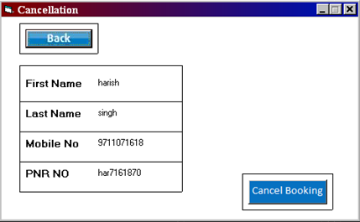

**Figure No- 11:- Cancellation screen of ticket**

**Validation specification**

1. PNR number should be there, without PNR number ticket cannot be cancelled.

3.2.2 List of data elements (comprising Field Name, Field Type, Field Size & description)

for each Output presented in the tabular form.

|  |  |  |  |
| --- | --- | --- | --- |
| **TICKET SCREEN** | | | |
| **Field Name** | **Field Type** | **Field Size(No of Character)** | **Description** |
| Depart_City | Varchar | 10 | flight departure city name |
| Arrival_City | Varchar | 10 | Flight arrival city name |
| Depart_Date | Varchar | 10 | Flight arrival date |
| Cabin | Varchar | 10 | Class (economy/business) |
| Flight_No | Varchar | 15 | unique No of flight |
| Depart_Hour | Number | 3 | Flight depart hour |
| Depart_Minute | Number | 3 | Flight depart minute |
| First_Name | Varchar | 20 | Contain first name |
| Last_Name | Varchar | 20 | Contain last name |
| Pnr_No | Varchar | 20 | System generated unique no |
| Eco_Price | Varchar | 10 | Price of one seat in economy class |
| Bust_Price | Varchar | 10 | Price of one seat in business class |

**Table No- 5:- Data elements for Ticket screen**

|  |  |  |  |
| --- | --- | --- | --- |
| **CANCELLATION SCREEN** | | | |
| **Field Name** | **Field Type** | **Field Size(No of Character)** | **Description** |
| First_Name | Varchar | 20 | passenger first name |
| Last_Name | Varchar | 20 | passenger last name |
| Mobile_No | Char | 15 | passenger mobile no |
| Pnr_No | Varchar | 20 | System generated unique no |

**Table No- 6:- Data elements for Cancellation screen**

**3.3 Input Specifications**:

3.3.1Detailed characteristics of contents (fields) to be included in each Input screen or

document.

**Flight searching**

1. Name of departure city
2. Name of arrival city
3. Departure date
4. Cabin/class

**Flight searching**

Class /Cabin

Departure Date

Arrival city

Departure city

**SEARCHH**

**Figure No- 12:- Screen of Flight Searching form**

**Validation searching**

a) Passenger’s name cannot be left blank.

b) Passenger’s address cannot be left blank.

c) Passenger’s contact should be there.

d) Passenger’s DOB details cannot be left undone.

e) Amount of seats cannot be left blank

f) Departure place & time cannot be left blank.

**Print ticket**

1. PNR no

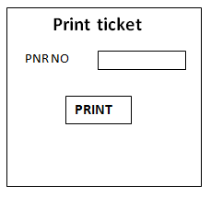

**Figure No- 13:- Screen of Print ticket**

**Cancellation screen**

1. PNR no

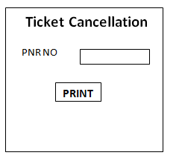

**Figure No- 14:- Ticket cancellation screen**

3.3.2List of data elements (comprising Field Name, Field Type, Field Size & description) for

each Input presented in the tabular form .

|  |  |  |  |
| --- | --- | --- | --- |
| **FLIGHT SEARCHING** | | | |
| **Field Name** | **Field Type** | **Field Size(No of Character)** | **Description** |
| Depart_City | Varchar | 10 | passenger departure city name |
| Arrival_City | Varchar | 10 | passenger arrival city name |
| Depart_Date | Varchar | 10 | passenger departure date |
| Cabin | Varchar | 10 | Class (economy/business) |

**Table No- 7:- Data elements for Flight screen**

|  |  |  |  |
| --- | --- | --- | --- |
| **PRINT TICKET** | | | |
| **Field Name** | **Field Type** | **Field Size(No of Character)** | **Description** |
| Pnr_No | Varchar | 20 | Passenger unique no |

**Table No- 8:- Data elements for Print ticket**

**3.4 Validation Specifications**:

3.4.1Description of the validation rules to be included for input/output, wherever required.

Validity Checks:-

a) Passenger’s name cannot be left blank.

b) Passenger’s address cannot be left blank.

c) Passenger’s contact should be there.

d) Passenger’s DOB details cannot be left undone.

e) Amount of seats cannot be left blank

f) Departure place & time cannot be left blank.

g) Only the data entry operator will be authorized to access the information. Passenger will only

be able to view their transaction history.

h) The total amount can never be negative.

**3.5 Database Specifications**

3.5.1Detailed characteristic of fields of each file/table included in the database are to be

tabulated with Field Name, Type, and Size & Description

|  |  |  |  |
| --- | --- | --- | --- |
| **CUSTOMER & RESERVATION DATABASE** | | | |
| **Field Name** | **Field Type** | **Field Size(No of Character)** | **Description** |
| Title | Varchar | 4 | Title of customer |
| First_Name | Varchar | 20 | First Name of the Ticket for whom its booked |
| Last_Name | Varchar | 20 | Last Name of the Ticket for whom its booked |
| Date_of_Birth_Day | Number | 2 | Age of passenger according to day |
| Date_of_Birth_Month | Char | 4 | Age of passenger according to month |
| Date_of_Birth_Year | Number | 4 | Age of passenger according to year |
| Mobile_No | Char | 15 | Contact number/ mobile number of passenger |
| Address_Line_One | Varchar | 50 | Address of passenger |
| Address_Line_Two | Varchar | 50 | Sub address of passenger |
| City | Varchar | 10 | City where passenger living |
| State | Varchar | 15 | State where passenger living |
| Country | Varchar | 15 | Country where passenger living |
| Pincode | Char | 8 | Area code of the passengers residential |
| Pnr_No | Varchar | 20 | Pnr no of the ticket registered/ reserved (system generated) |
| Flight_No | Varchar | 15 | Unique flight no of plane |
| Cabin | Varchar | 10 | Section in which the seat reserved |

**Table No- 9:- Data elements of Customer database**

|  |  |  |  |  |
| --- | --- | --- | --- | --- |
| **FLIGHT DATABASE** | | | | |
| **Field Name** | **Field Type** | | **Field Size(No of Character)** | **Description** |
| Flight_Company | | Varchar | 15 | The name of the flight company it belongs to. |
| Depart_City | | Varchar | 10 | The city from where the flight will take off |
| Arrival_City | | Varchar | 10 | The city where the flight will land |
| Depart_Date | | Varchar | 10 | Date of flight take off |
| Depart_Hour | | Number | 3 | Time in hour of flight’s take off time |
| Depart_Minute | | Number | 3 | Time in minutes of flight’s take off time |
| Eco_No_of_Seat | | Number | 4 | Total economy seats in flight |
| Eco_Price | | Varchar | 10 | Price of one economy seat |
| Bust_No_of_Seat | | Number | 4 | Total business seats in flight |
| Bust_Price | | Varchar | 10 | Price of one business seat |
| Flight_No | | Varchar | 15 | Unique flight no system genrated |

**Table No- 10:- Data elements of Flight database**

|  |  |  |  |
| --- | --- | --- | --- |
| **Login Table** | | | |
| **Field Name** | **Field Type** | **Field Size(No of Character)** | **Description** |
| **User name** | **Varchar** | **10** | **Username** |
| **Password** | **Varchar** | **20** | **Password** |

**Table No- 11:- Data elements of Login**

**3.6 Processing Logic:**

3.6.1 Programme Flow Chart

Enter UID and Passwd

NO

Access Granted

YES

Take query from passenger

Enter PNR NO

Enter Depart city ,date and arrival city

Booking

Cancellation

Query

Found

Found

Find best solution and solve the query

NO

No

Yes

Print ticket

yes

Cancel the ticket

**Figure N0-15: Data Flow Diagram of final program chart**